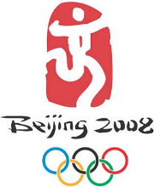
Illustrator Final Project
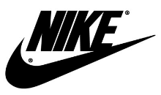
Personal Logo 100 points

A logotype, commonly known as a logo, is the graphic element of a trademark or brand, which is set in a special typeface/font, or arranged in a particular, but legible, way. The shape, color, typeface, etc. should be distinctly different from others in a similar market.

Before you start designing your personal logo:

- Elements of Design https://videos-tv.adobe.com/2013-04-25/6c3b881f20e0303d6b063c089813ac91.mp4
- Understand how the brain interprets designs by looking at the Gestault theories: https://www.youtube.com/watch?v=yadmpXUQ68A. You will have to include one in your logo.

Gestault Principles quick reference: http://graphicdesign.spokanefalls.edu/tutorials/process/gestaltprinciples/gestaltprinc.htm

- Understand Color Theory:
Read through http://www.color-wheel-pro.com/color-theory-basics.html & http://www.color-wheel-pro.com/color-schemes.html

Complete the below Color Meaning table in a separate Word document.
http://www.color-wheel-pro.com/color-meaning.html
Red | Red is an emotional color e.x. anger, love, desire, passion
Orange
Yellow
Green
Blue
White
Black
Which colors best describe you and why?

Objective:
You are creating a personal logo for YOU, which you can use personally as well as professionally.
It is important to have a logo that represents you and that is also memorable. This is something you can use now and in the future.

The Symbol: the symbol (mark) should generate positive associations and visual interest. The association may be with a skill, service, art (CoSA concentration), character attribute, person, place, or thing with which you identify with or want to be identified with.
The Logo: your name

Specifications:
Your mark (symbol) should be simple and powerful enough to be recognizable as well as read clearly when large or small. It should also be still readable and recognizable when it needs to be in black and white.

Final Project Requirements

PART 1: 25 points
- Create a word list of words that describe you, what you do, the vibe you want to convey with our logo etc.
- You MUST use at least ONE of Gestault’s Principles in your logo.
- Using your layered word list, start sketching ideas of your mark/logo.
Create 3 thumbnail sketches of ideas.
  - We will narrow down to which logo is best through critique and your personal preference.
  - -MAKE THUMBNAIL SKETCHES WELL THOUGHT OUT LIKE THE ONES BELOW:
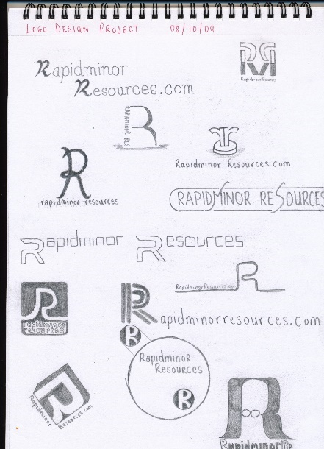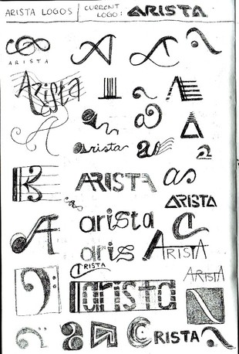

PART 2: 75 points total
Create your chosen logo in Illustrator 50 points (see rubric below)
On a Word document, write a Statement of Purpose that answers these questions: 25 points
- Defend which ONE of Gestault’s Principles you used in your logo, how?
- Identify problems /challenges you faced and how you worked through them.
- What “real world” connections did you find in doing this project?
- What did you like and dislike about the project?

Logo Rubric 50 points

 | Excellent 45-50pts | Good 40-45pts | Satisfactory 35-40pts | Poor less 35pts
Logo | This Logo clearly expresses the product or services through the use of symbols and manipulation of the letters.  Gestault principle clearly used. | This Logo adequately expresses the product or services through the use of symbols and manipulation of the letters.  Gestault principle possibly used. | This Logo expresses the product or services through the use of symbols and manipulation of the letter in a limited fashion.  Gestault principle not obviously used. | This Logo does not express the product or services through the use of symbols and manipulation of the letters.  Gestault principle NOT used.
Craftsmanship/ Skill | The artwork shows excellent craftsmanship, and attention to detail. | The artwork shows average craftsmanship and attention to detail. | The artwork shows below average craftsmanship and little attention to detail. | The artwork shows poor craftsmanship and no attention to detail.
Creativity/ Originality | The artwork clearly demonstrates personal expression. Solution is very inventive. | The artwork demonstrates an average amount of personal expression. Demonstrates some inventiveness. | The artwork demonstrates little personal expression and inventiveness. | The artwork lacks evidence of personal expression and inventiveness.
Design | The artwork demonstrates excellent use of color. The design easy to understand and is visually compelling. Can be shrunk down to ½” and very readable. | The artwork demonstrates good use of color. The design relatively easy to understand and is somewhat visually compelling.  Can be shrunk down to ½” and semi readable. | The artwork demonstrates poor choice of color. The design is difficult to understand and is confusing.  Can be shrunk down to ½” and not readable. | The artwork lacks thoughtful design.  Can be shrunk down to ½” and not readable.
Use of Time | The student put forth the effort required and used class time well. | The student put forth effort and used class time adequately. | The student put forth little effort; during class time worked partially on project. | The student put forth no effort or the project was not completed; class time was not used well.
Illustrator Software Knowledge and tool use | Displays deep understanding of vector tools. Excellent use of the pen tool, pathfinder panel to create compound shapes, gradients, text on a path, rotation, custom swatches/gradients, drop shadows, etc.… | Displays an understanding of vector tools. Adequate use of the pen tool, pathfinder panel to create compound shapes, gradients, text on a path, rotation, custom swatches/gradients, drop shadows, etc.… | Displays a basic understanding of vector tools. Minimal use of the pen tool, pathfinder panel to create compound shapes, gradients, text on a path, rotation, custom swatches/gradients, drop shadows, etc.… | poor understanding of vector tools. Little to no use of the pen tool, pathfinder panel to create compound shapes, gradients, text on a path, rotation, custom swatches/gradients, drop shadows, etc.…

GESTAULT PRINCIPLES:
Use at least one in your personal logo.
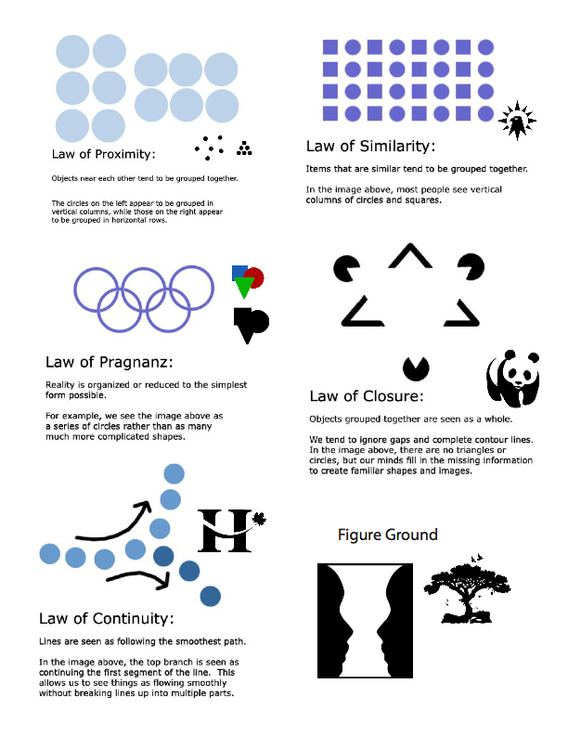

Think about what color(s) will be in your logo and what the color says to the viewer.
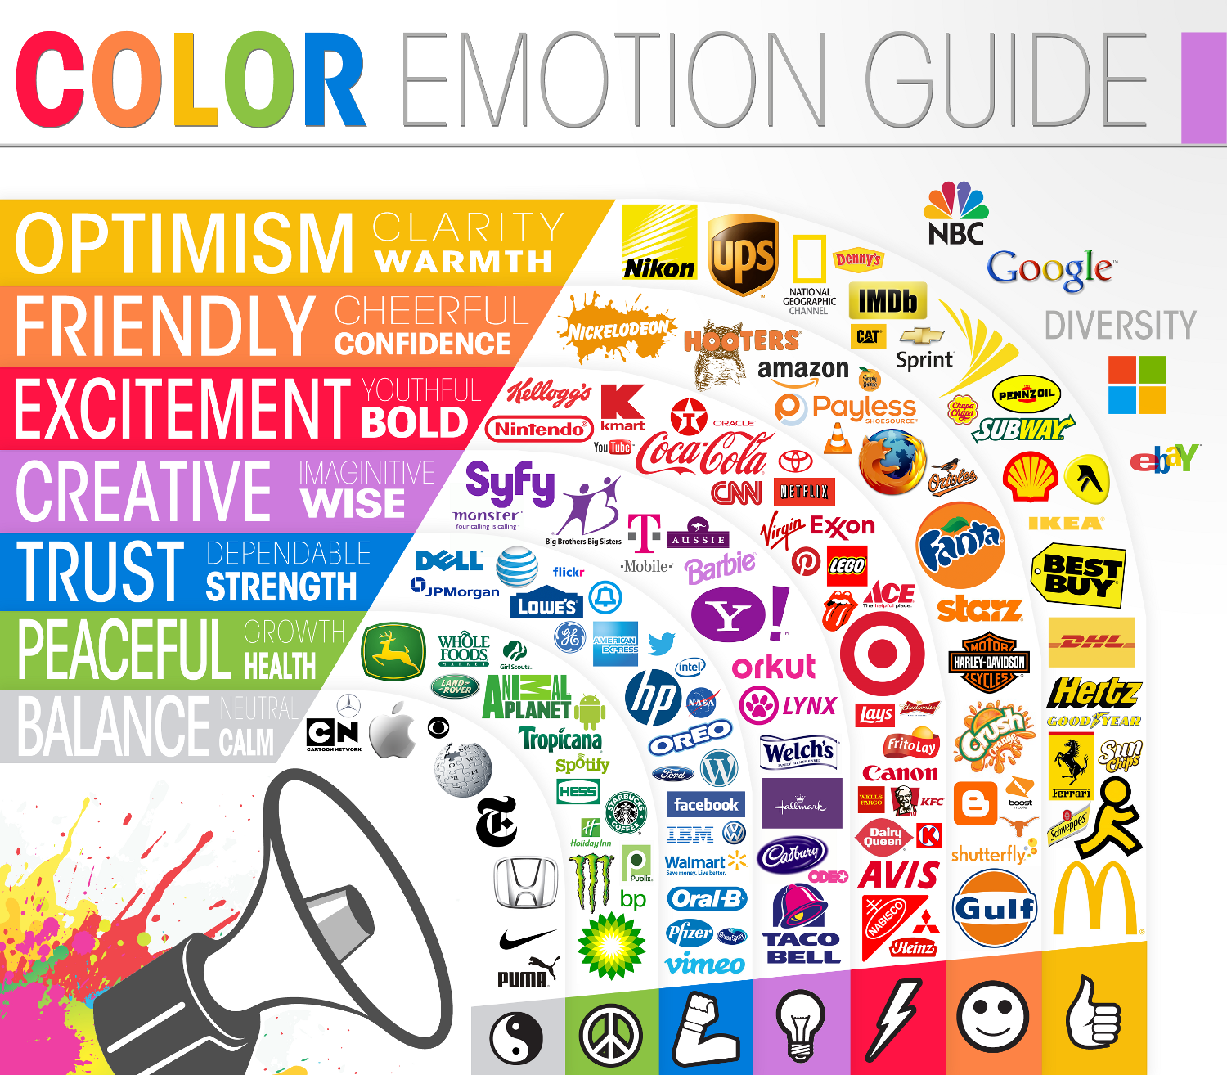

Personal logo examples:
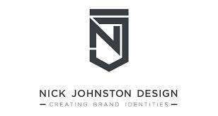
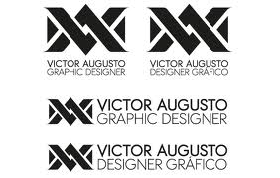
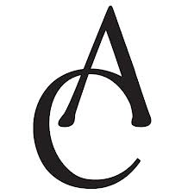

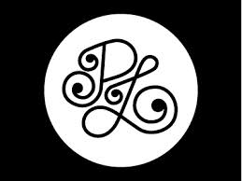

Below, see the different logo’s mark (symbol) with text taken out. The successful ones that have been branded well no longer need text. Can you easily spot some Gestault principles?

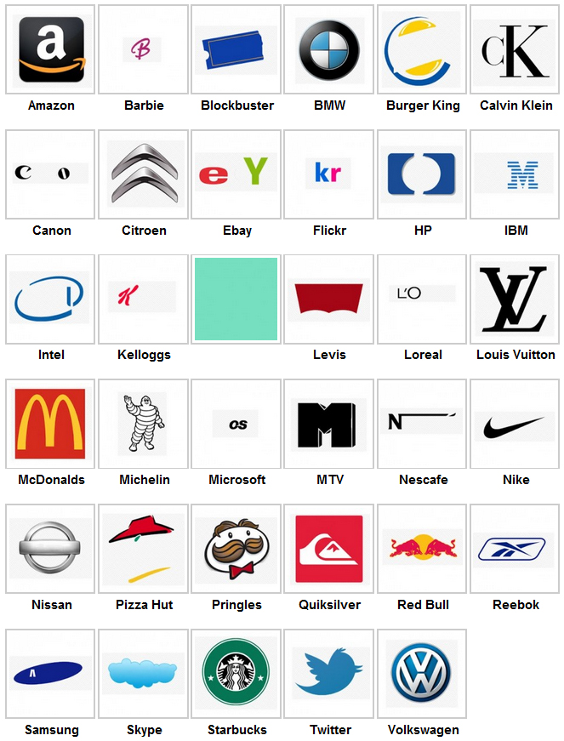

Logo History and Future Predictions
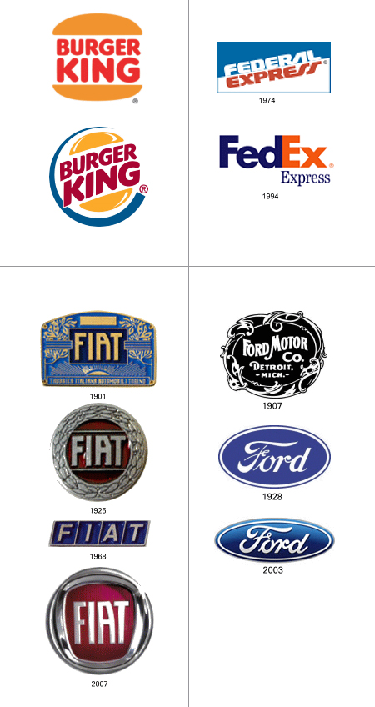
Apple:
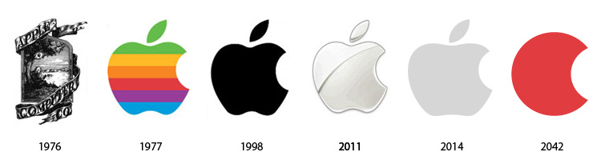
Firefox:
IBM:
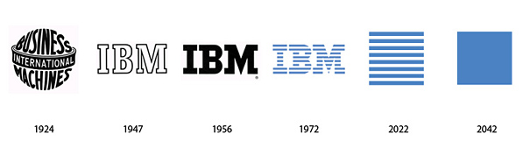
Starbucks:
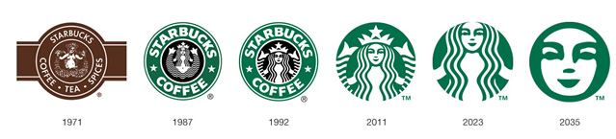
Microsoft:
This was a 2011 prediction
